Daylight LED Bulb

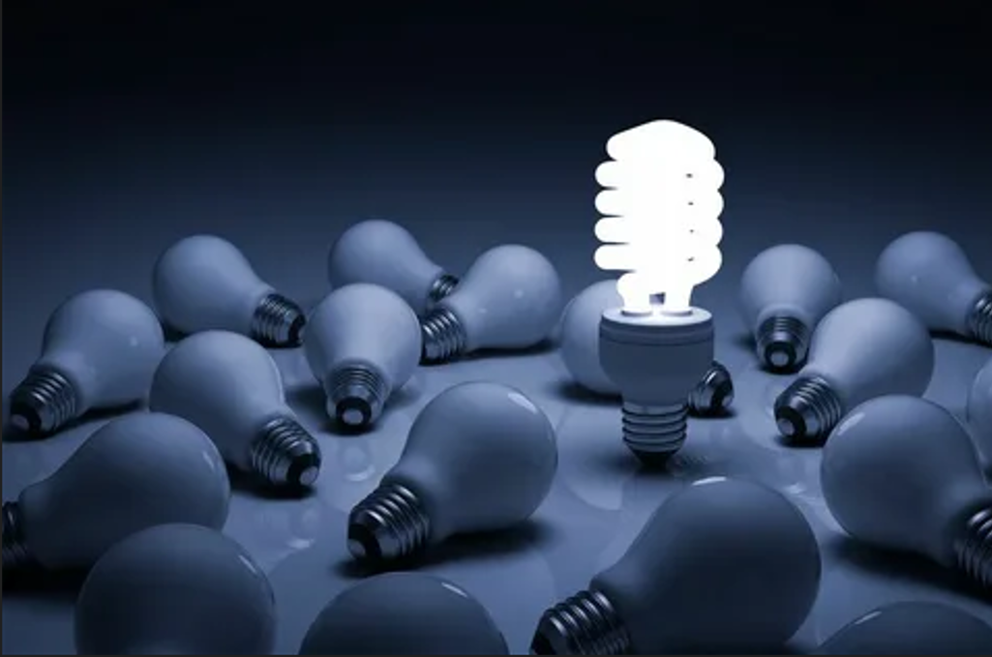

#### ****Description:****

**Daylight LED Bulbs** are energy-efficient lighting solutions designed to mimic natural daylight, providing bright and clear illumination. These bulbs are perfect for spaces where accurate color representation and high visibility are essential, such as offices, kitchens, and workspaces. With a high color rendering index (CRI), Daylight LED Bulbs enhance focus, productivity, and overall well-being.

* **Technology:** LED.
* **Compatibility:** Standard E26/E27 base (fits most fixtures).
* **Bulb Type:** A19 (standard bulb shape), PAR38 (floodlight shape).
* **Wattage:** 9W (equivalent to 60W incandescent).
* **Lumens:** 800 lumens (A19), 1200 lumens (PAR38).
* **Color Temperature:** 5000K-6500K (daylight white).
* **Dimmable:** Yes (select models).
* **Lifespan:** 25,000 hours.
* **Energy Efficiency:** Energy Star certified.
* **Color Rendering Index (CRI):** 90+ (excellent color accuracy).

#### ****Key Features:****

* **Natural Daylight:** Mimics natural sunlight, reducing eye strain and improving visibility.
* **Energy-Efficient:** Uses up to 85% less energy than traditional incandescent bulbs.
* **High CRI:** Ensures accurate color representation, ideal for tasks requiring precision.
* **Dimmable Options:** Available in dimmable models for adjustable brightness.
* **Long Lifespan:** Lasts up to 25,000 hours, reducing the need for frequent replacements.
* **Versatile Use:** Suitable for offices, kitchens, workshops, and more.

#### ****Pricing:****

* **Single Bulb (A19):** $9.99
* **Single Bulb (PAR38):** $14.99
* **4-Pack (A19):** 34.99(34.99(8.75 per bulb)
* **4-Pack (PAR38):** 54.99(54.99(13.75 per bulb)

#### ****Where to Use:****

* **Offices:** Enhance focus and productivity with bright, natural light.
* **Kitchens:** Improve visibility for cooking and food preparation.
* **Workshops:** Ensure accurate color representation for detailed tasks.
* **Living Rooms:** Create a bright and inviting atmosphere.
* **Retail Stores:** Highlight products with clear and vibrant lighting.

### ****Customer Reviews:****

* ⭐⭐⭐⭐⭐ "These Daylight LED Bulbs are amazing! They provide bright, natural light that makes my workspace so much more comfortable." – Sarah L.
* ⭐⭐⭐⭐ "Great value for the price. The bulbs are bright, and the light is very natural. Highly recommend for anyone looking to upgrade their lighting." – James T.
* ⭐⭐⭐⭐⭐ "I love how energy-efficient these bulbs are. The high CRI makes a huge difference in color accuracy." – Emily R.

### ****How to Order:****

1. Visit our website: [www.brightworldlighting.com](http://www.brightworldlighting.com/)
2. Select your preferred bulb type and pack size (Single or 4-Pack).
3. Add to cart and proceed to checkout.
4. Enjoy free shipping on all orders over $50!

### ****Warranty and Support:****

* **Warranty:** 2-year limited warranty covering manufacturing defects.
* **Customer Support:** Contact us at [support@brightworldlighting.com](mailto:support@brightworldlighting.com) or call +1-800-123-4567 for assistance.

### ****Visual Representation:****

Include high-quality images of the Daylight LED Bulbs in different settings (e.g., office, kitchen) to showcase their versatility and design.